(ELECTRONIC LABORATORY LOGISTICS MANAGEMENT INFORMATION SYSTEM) **e-LABLMIS**

e-LABLMIS

USER INSTRUCTION MANUAL

Ver.1.1

e-LABLMIS

Contents

What is e-LABLMIS? 2

Starting e-LABLMIS 3

System Admin (National Admin) Overview 4

Dashboard 4

System Configurations 4

Summary 4

Regions…………………………………………………………………………………………………………………………….…….4

Facilties………………………………………………………………………………………………………………………………….4

Items………………………………………………………………………………………………………………………………….….4

UOM (Unit of Measure)……………………………………………………………………………………………….…….….4

Users…………………………………………………………..………………………………………………………………….….….4

Roles………..………………………………………………..……………………………………………………….…………….….4

Service Data 16

Summary: 16

Viral Load 16

EID 16

Logistics Data 19

Summary: 19

Report 21

Summary 21

Service Data Summary……………………………………………………………………………………………………………21

Viral Load……………………………………………………………………………………………………………………21

EID……………………………………………………..………………………………………………………………………21

Logistics Data Summary………………………..……………….……………………………………………………………..24

Consolidated………………………..…………………………………….…………………………………………………….…..24

Visualized Data………………………………………………….…………………………………………….……………….…..24

Audit Trail……………………….…..…………………………………….………………………………………………………....24

Regional Admin Overview 26

System Configuration 26

Service Data 26

Logistics Date 27

Report 27

User (System User) Overview 28

Profile 28

Service Data 29

Logistics Date 29

Table of Figures

Figure 1: Dashboard 11

Figure 2: Regions 12

Figure 3: Adding a New Region 13

Figure 4: Editing Region 13

Figure 5: Facilities 14

Figure 6: Adding a New Facilities 14

Figure 7: Edit Facilities 14

Figure 8: Item 15

Figure 9: Adding New Item 16

Figure 10: Edit Item 16

Figure 11: UOM (Unit of Measure) 17

Figure 12: Add New UOM 18

Figure 13: Editing UOM 18

Figure 14: Users 19

Figure 15: Add New User 20

Figure 16: Edit User 20

Figure 17: Roles 21

Figure 18: Edit Role 22

Figure 19: Viral Load 22

Figure 20: Add New Viral Load 23

Figure 21: Edit Viral Load 23

Figure 22: EID 24

Figure 23: Add New EID 25

Figure 24: Edit EID 25

Figure 25: Logistics Data 26

Figure 26: Add New Logistics Data 26

Figure 27: Edit Logistics Data 27

Figure 28: Viral Load Report 28

Figure 29: EID Report 29

Figure 30: Logistics Data Report 29

Figure 31: Consolidated Report 30

Figure 32: Visualized Data Report 30

Figure 33: Audit Trail Report 31

Figure 34: Users Home Page 34

Figure 35: User Profile 34

# 

# What is e-LABLMIS?

The Electronic Laboratory Logistics Management Information System, is a Web-based application that can be installed in a local, district, or national laboratory. It a tool that can be used to standardize data, which improves the ability to run useful reports and can be used to give a realistic picture of laboratory services and assist staff to get accurate data and result. Easy access of monthly data. The features of the ELABLMIS include:

* Entry of service data for the month and year (Viral Load)
* Entry of service data for the month and year (EID)
* Entry of Logistics Service Data for the month and year
* System Configuration( Regions, Facilities, Item, Unit of Measure, Users, Role)
* Report (Service Data Summary, Logistics Data Summary, Consolidated, Visualize Data, Audit Trail)

As with the properly implemented electronic record system, e-LABLMIS may be found over time to improve data accuracy and reduce cost of it implementation. Benefits of e-LabLMIS:

* Reduced the burden of using of adding data as the system does that right after data is entered.
* Improve constancy of data entry
* Ability download pdf report of the data in the system
* Ability to monitor data trends at the regional and national level
* Print out visualized report in place plotting records
* Print out report that looks like that of the spread sheet which was being used.

# Starting e-LABLMIS

To start the e-LabLMIS, type in this address <http://www.elabinventory.perkycare.org/login> in your url and press the enter key. You will then see a page requesting login information you must then enter your credentials to proceed

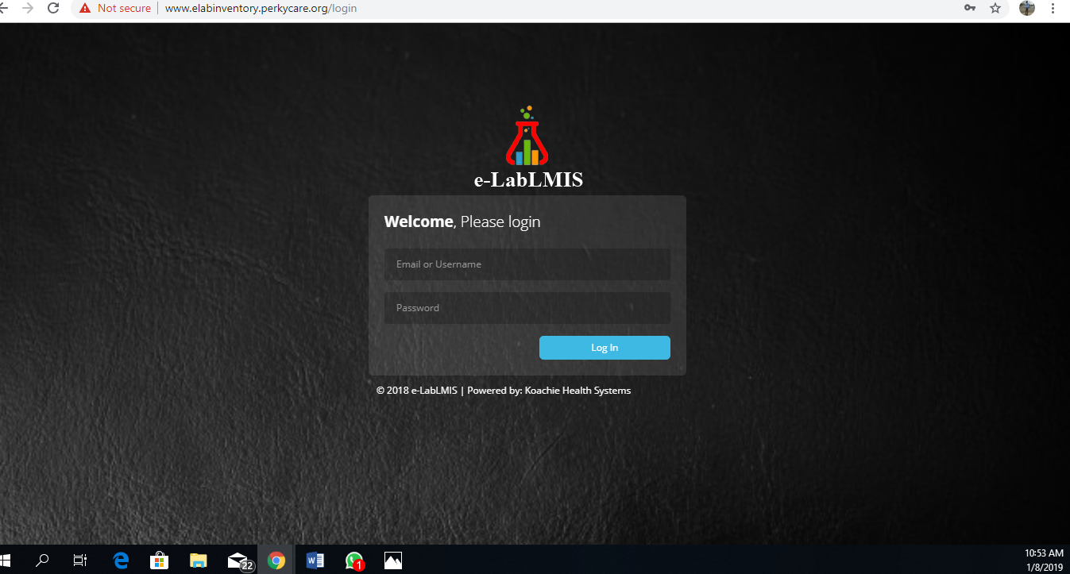

After your session is complete, click the logout button in the top right corner of the screen. This will pop up a window that will request you to confirm if you want to log out of your session, you can click on **YES** to logout of the system or alternatively click **NO** if you do not wish to logout.

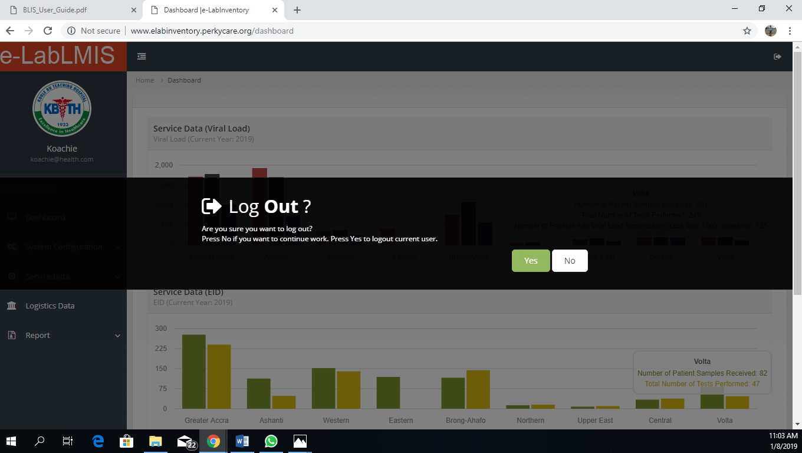

# System Admin (National Admin) Overview

The system admin/National Admin gives you the ability to add, edit and delete users as well as change the system configuration settings. As a System admin you can also print and generate report as well as also see the data that is being entered in for the regions.

When you log in as a System Admin/National Admin, you can see the System Admin/National Admin home page

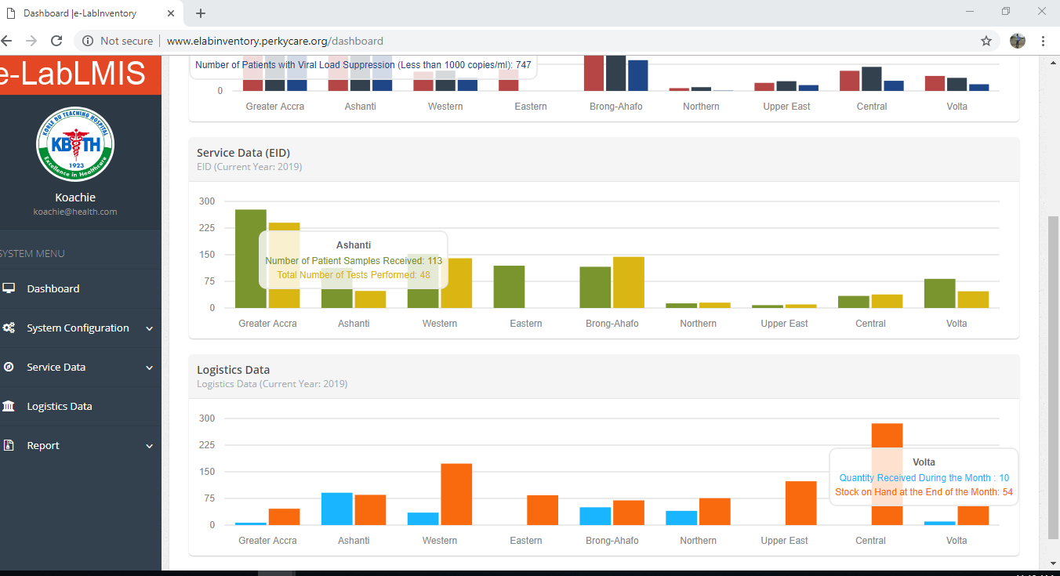

Figure : Dashboard

To switch through the System Menu click on the tab that is displaced on the same screen.

## Dashboard

The dashboard provides a general over view of data being entered into the system in a graphical mode. This data is based on regions so without going further into the system the dashboard provides a quick data summary of the e-LABLMIS.

## System Configurations

The e-labLMIS System Configurations allows you to set the system up, what regions, facilities, Items, unit of measure, users and roles should be in the system. This is done on the same page by clicking on the tab of the navigation. This is done by the System Admin/National Admin

The various pages of this section are explained in the following pages:

### Summary

This navigation displays the Regions, Facilities, Items, Unit of Measure, Users and Roles

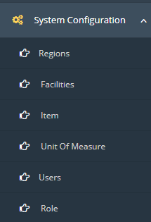

#### Regions

Allows you to add, edit and delete Regions

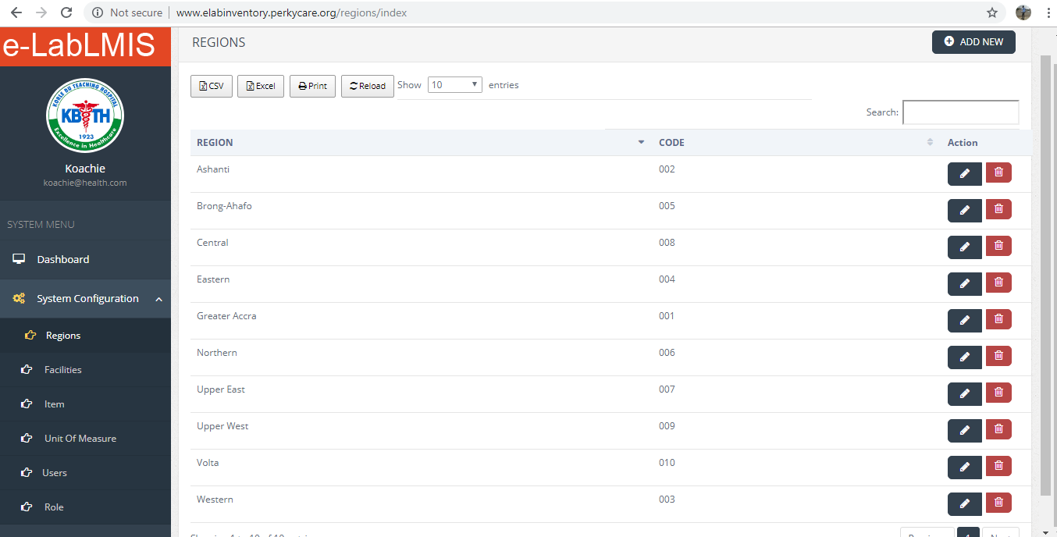

Figure : Regions

From Figure 2 there is a table listing all the regions in the system from here region can be added by clicking on the button at the top right Conner labeled “ADD NEW”, regions can also be edited by clicking on the pencil in the action button the same applies to deleting a region.

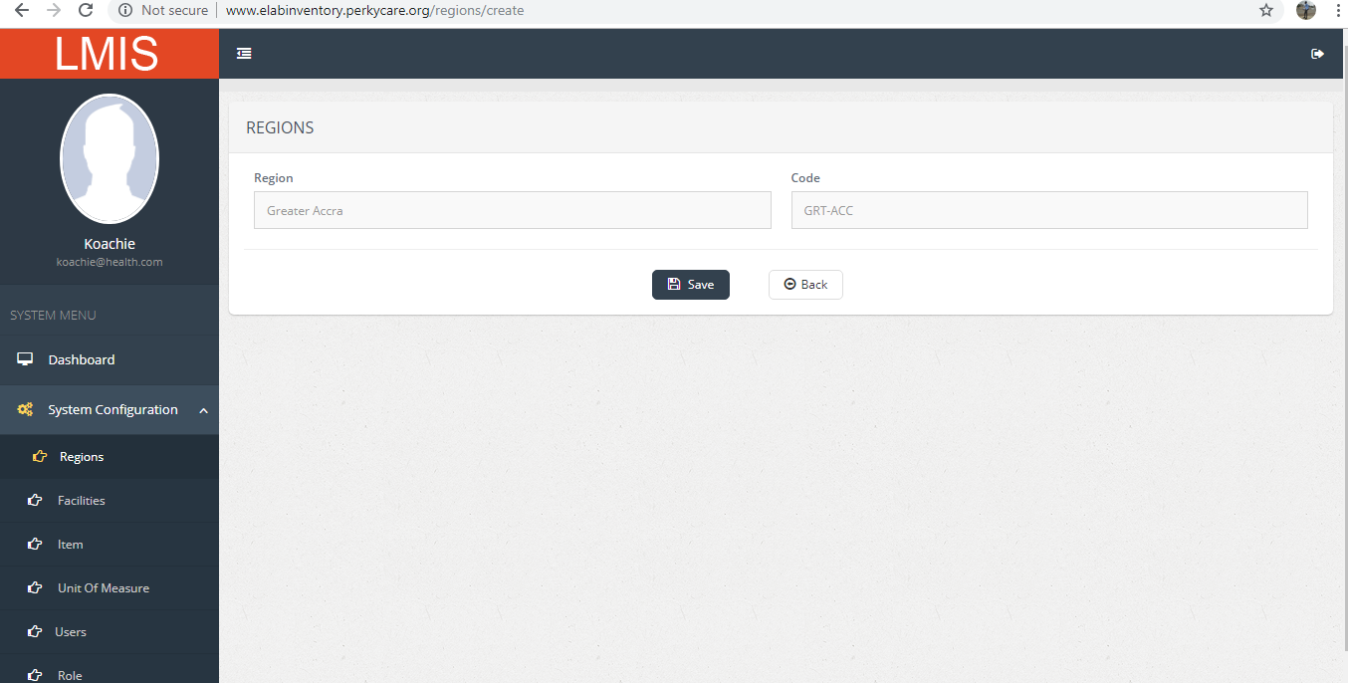

Figure : Adding a New Region

From Figure 3 it allows you to add a new region, this done by filling the input fields and clicking on the save button to save the record. The back button return you to the list of records in the system.

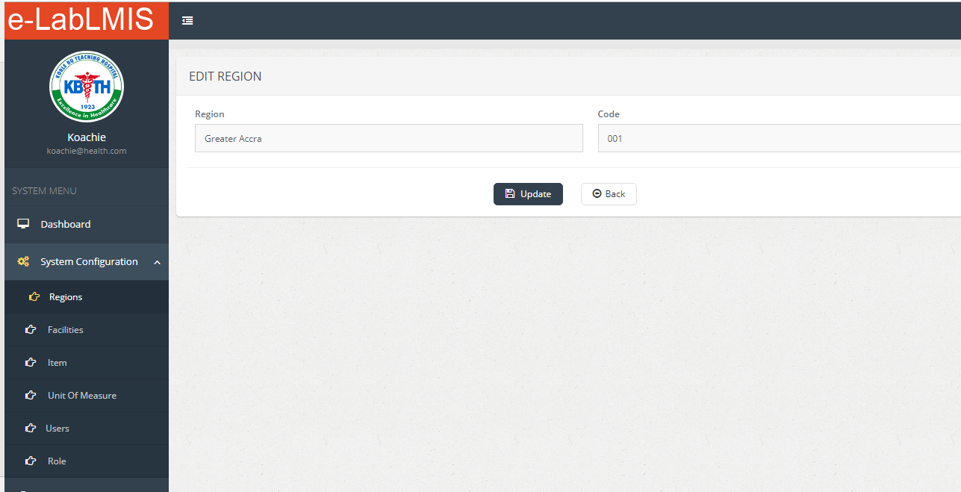

Figure : Editing Region

From Figure 4 it allows you to edit region, this done by making changes to the record in the fields and clicking on the Update button to save the record. The back button return you to the list of records in the system.

#### Facilities

Allows you to add, edit and delete Facilities

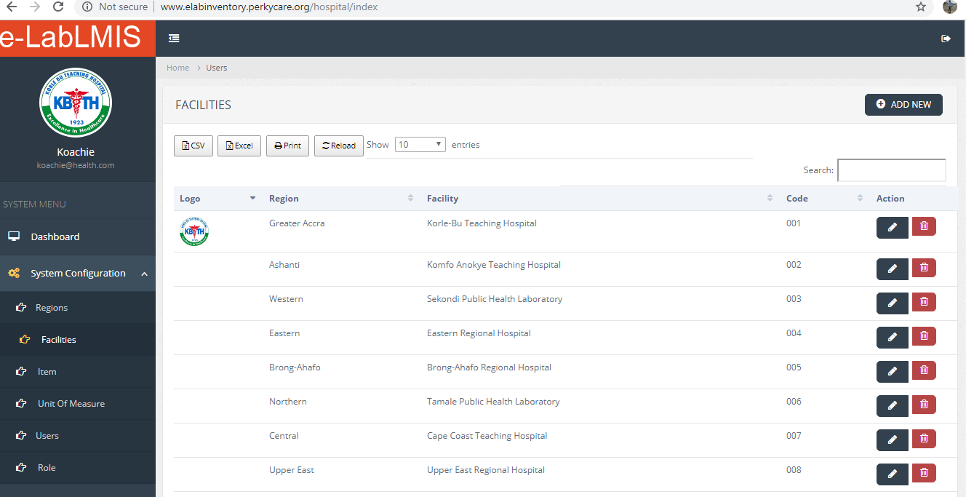

Figure : Facilities

From Figure 5 there is a table listing all the Facilities in the system from here facilities can be added by clicking on the button at the top right Conner labeled “ADD NEW”, Facilities can also be edited by clicking on the pencil in the action button the same applies to deleting a Facilities

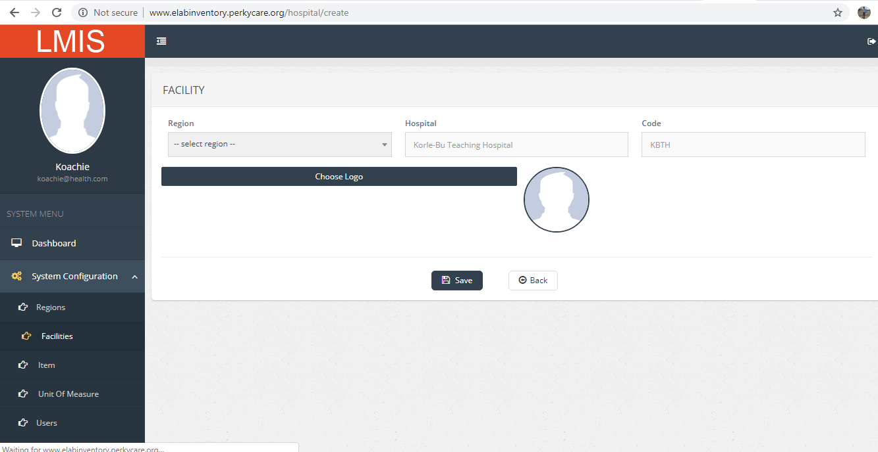

Figure : Adding a New Facilities

From Figure 6 it allows you to add a new Facility, this done by filling the input fields from here you can also add a Facility Logo and clicking on the save button to save the record. The back button return you to the list of records in the system.

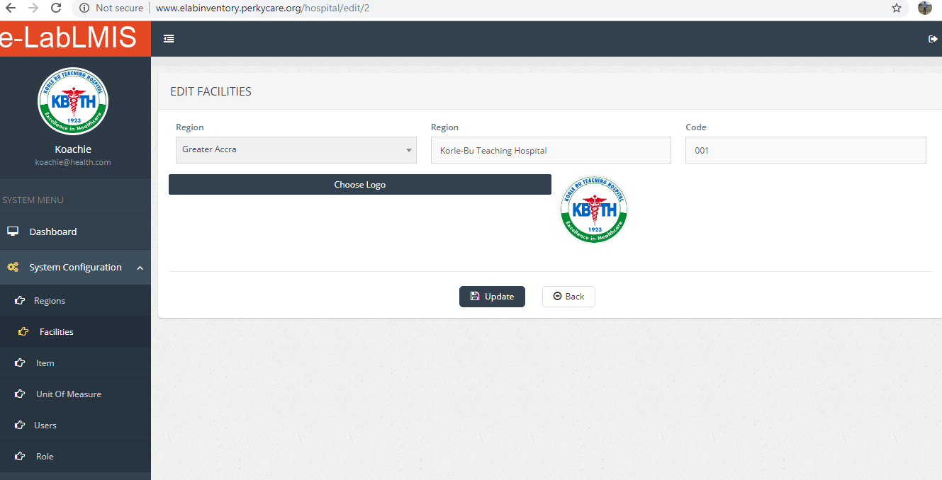

Figure : Edit Facilities

From Figure 7 it allows you to edit Facilities, this done by making changes to the record in the fields and clicking on the Update button to save the record. The back button return you to the list of records in the system.

#### Item

Allows you to add, edit and delete Item

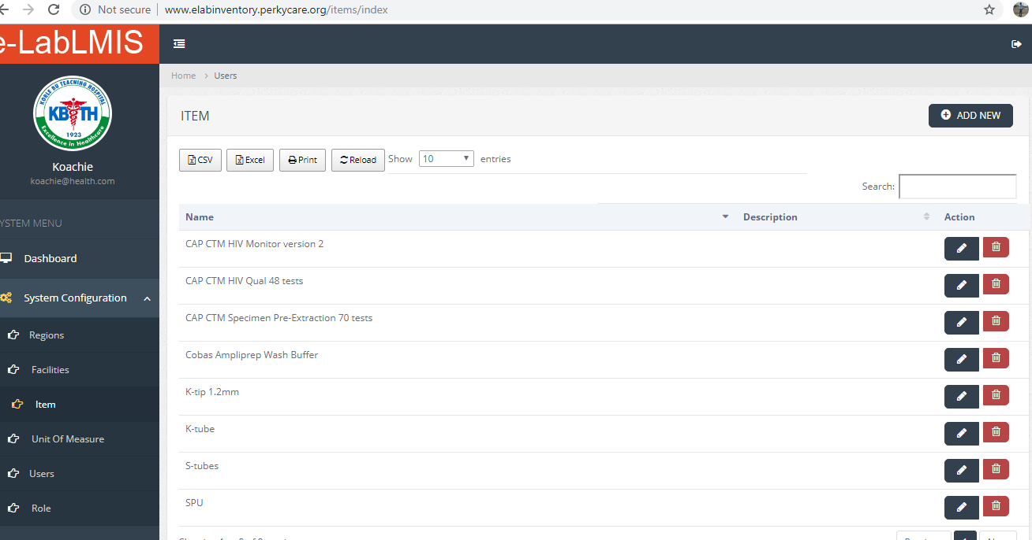

Figure : Item

From Figure 8 there is a table listing all the Items in the system from here Items can be added by clicking on the button at the top right Conner labeled “ADD NEW”, Items can also be edited by clicking on the pencil in the action button the same applies to deleting a Items.

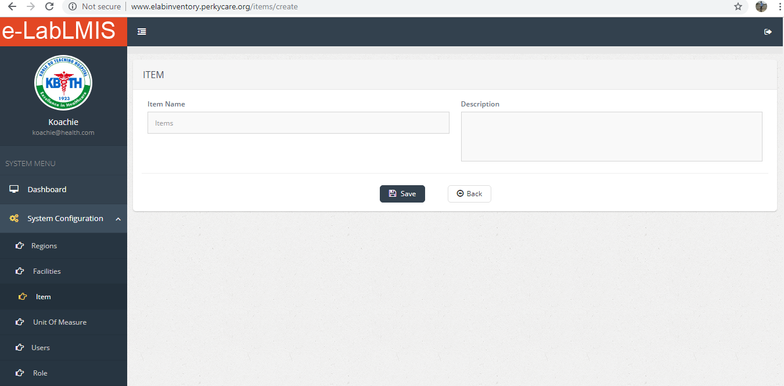

Figure : Adding New Item

From Figure 9 it allows you to add a new Item, this done by filling the input fields and clicking on the save button to save the record. The back button return you to the list of records in the system.

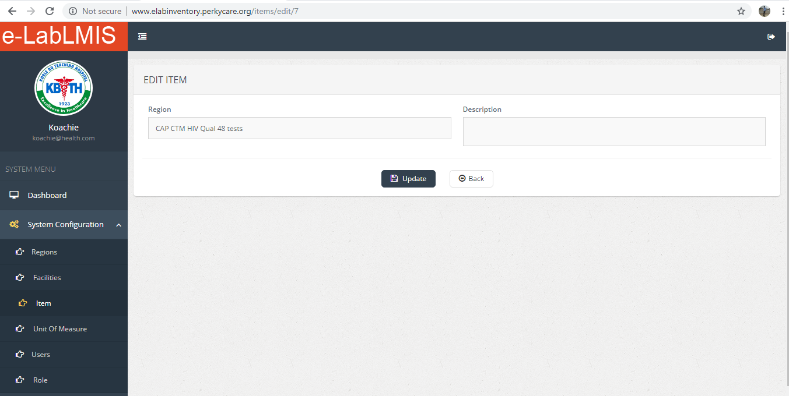

Figure : Edit Item

From Figure 10 it allows you to edit Item, this done by making changes to the record in the fields and clicking on the Update button to save the record. The back button return you to the list of records in the system.

#### UOM (Unit of Measure)

Allows you to add, edit and delete UOM

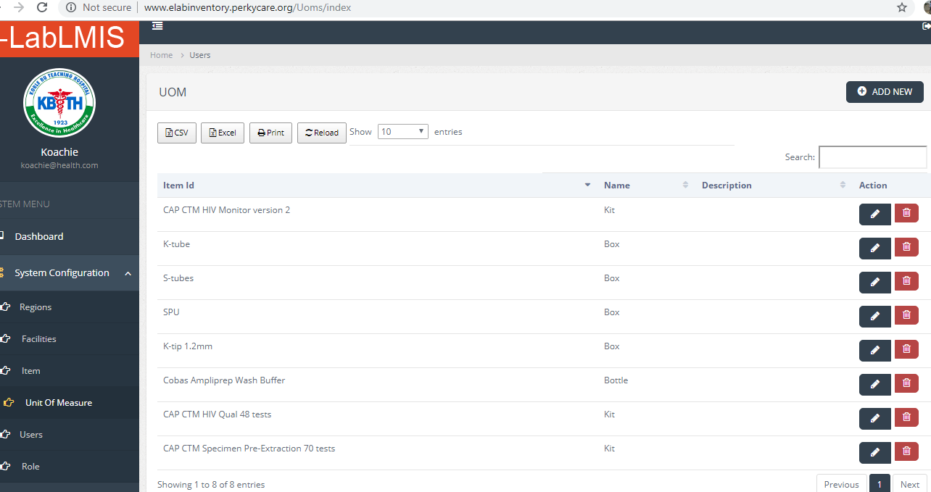

Figure : UOM (Unit of Measure)

From Figure 11 there is a table listing all the UOM in the system from here Items can be added by clicking on the button at the top right Conner labeled “ADD NEW”, Facilities can also be edited by clicking on the pencil in the action button the same applies to deleting a UOM

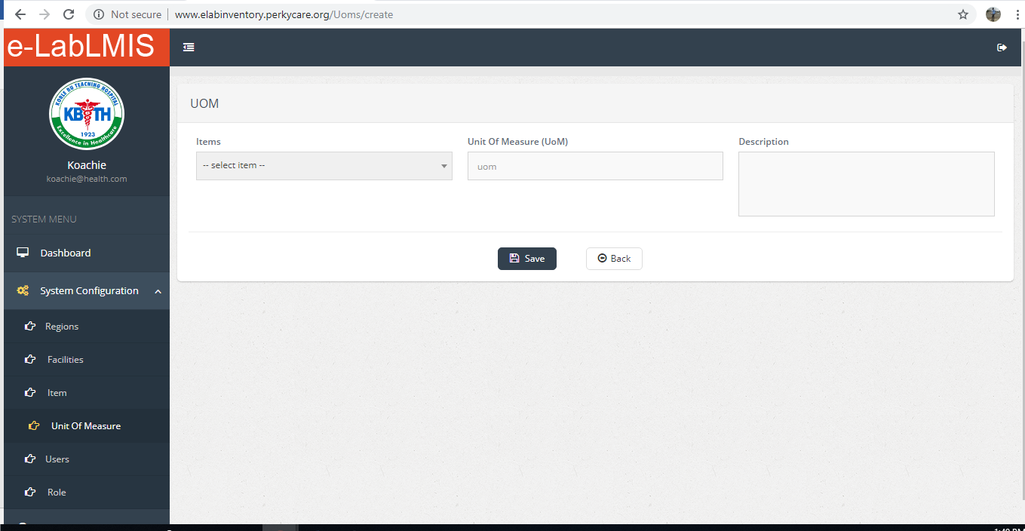

Figure : Add New UOM

From Figure 12 it allows you to add a new UOM, this done by filling the input fields and clicking on the save button to save the record. The back button return you to the list of records in the system.

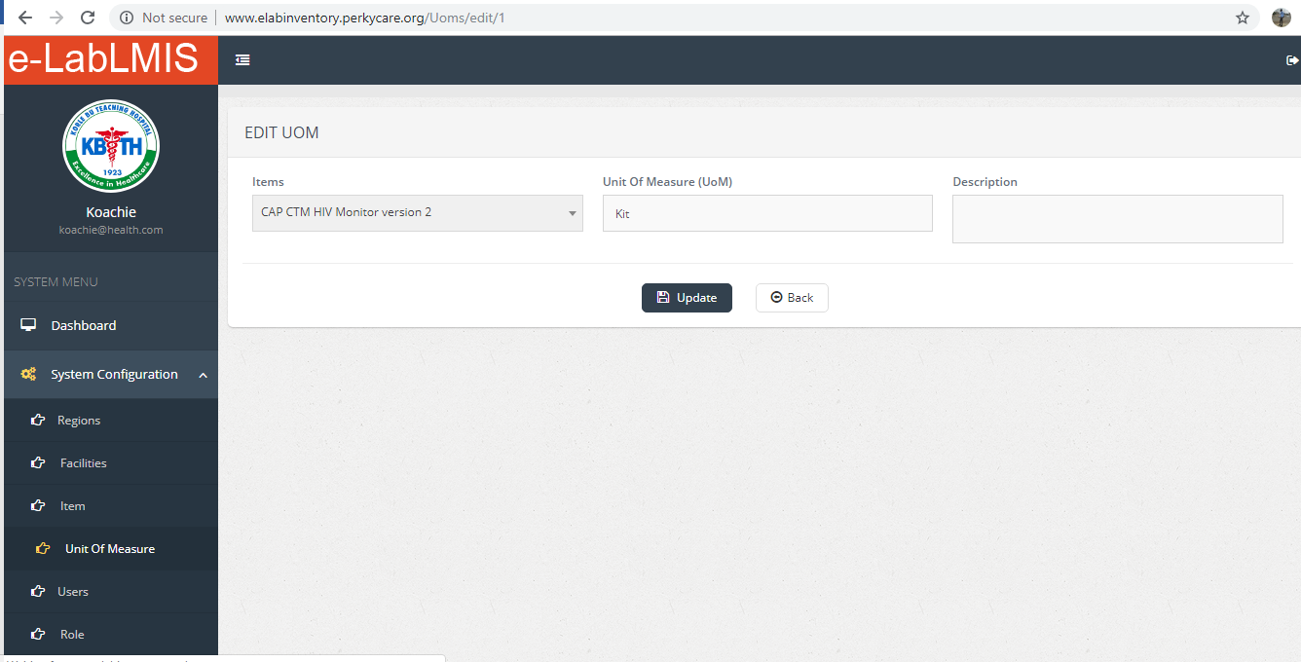

Figure : Editing UOM

From Figure 13 it allows you to edit UOM, this done by making changes to the record in the fields and clicking on the Update button to save the record. The back button return you to the list of records in the system.

Service Data

#### Users

Allows you to add, edit, block and delete User

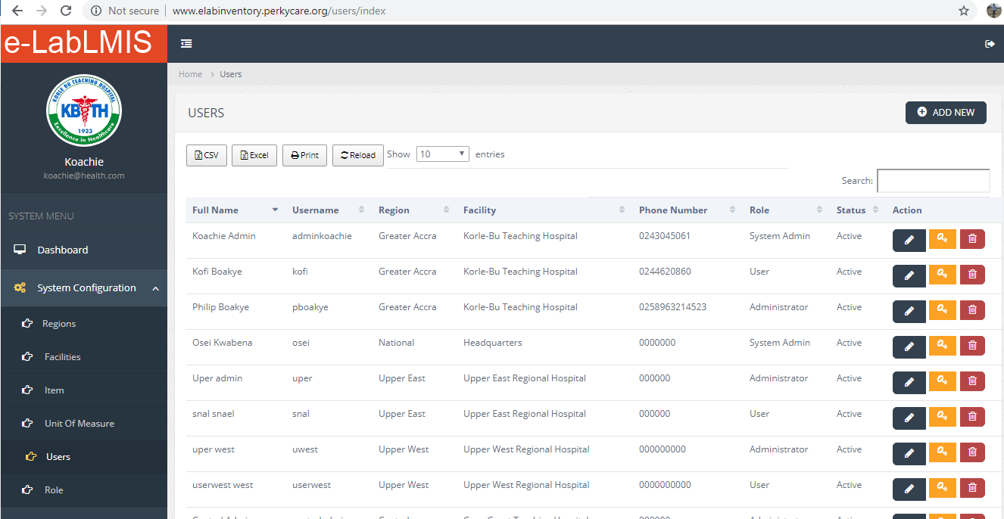

Figure : Users

From Figure 14 there is a table listing all the Users and their respective regions as well as facilities they belong to, in the system from here Users can be added by clicking on the button at the top right Conner labeled “ADD NEW”, User can also be edited by clicking on the pencil in the action button, user can also be blocked from having access to the system by clicking on the key, the same applies to deleting a User

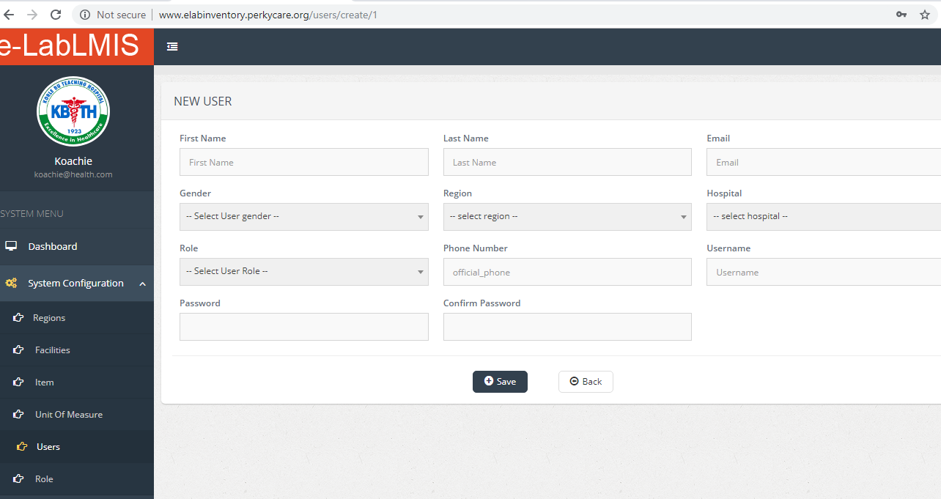

Figure : Add New User

From Figure 15 it allows you to add a new User, this done by filling the input fields and clicking on the save button to save the record. The back button return you to the list of records in the system.

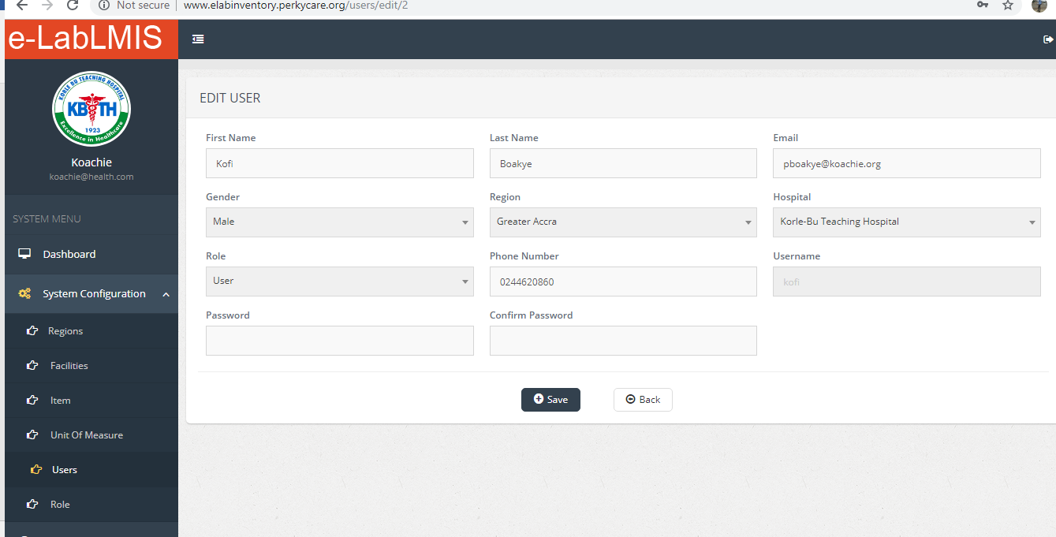

Figure : Edit User

From Figure 16 it allows you to edit User, this done by making changes to the record in the fields and clicking on the Save button to save the record. The back button return you to the list of records in the system.

#### Role

Allows you to edit role

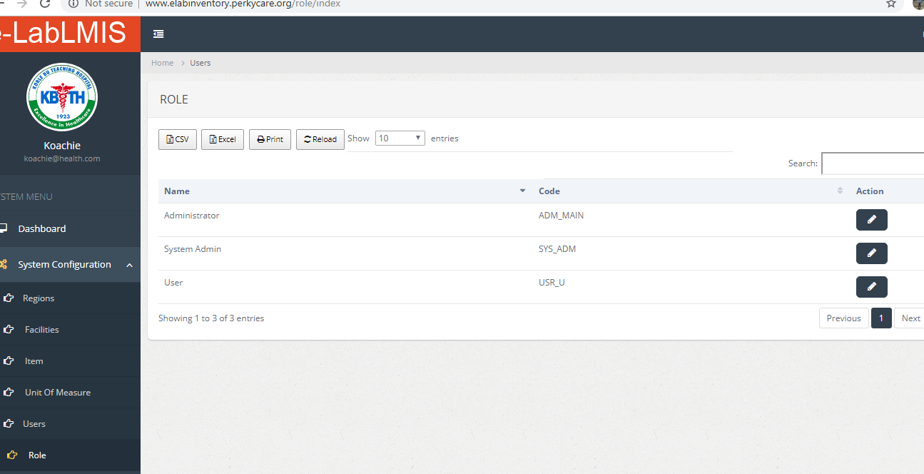

Figure : Roles

From Figure 17 there is a table listing all the Role it allows you to edit the Roles.

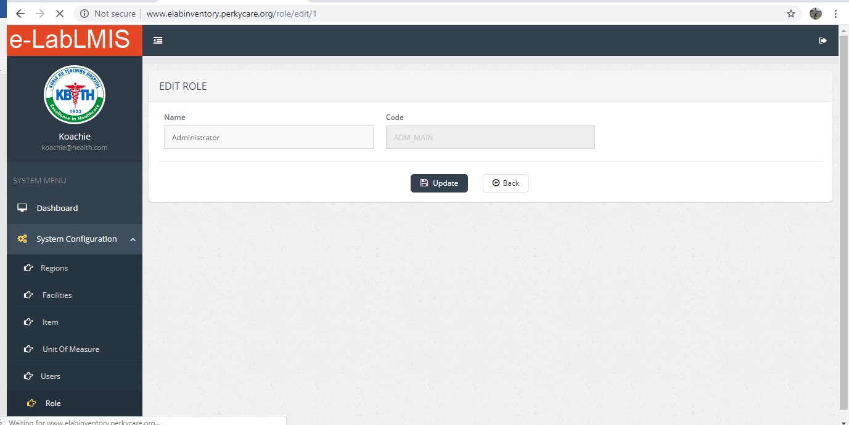

Figure : Edit Role

From Figure 18 it allows you to edit Role, this done by making changes to the record in the fields and clicking on the Update button to save the record. The back button return you to the list of records in the system.

## Service Data

The e-labLMIS Service Data allows you to enter records into the system Viral Load and EID. The various pages of this section are explained in the following pages:

### Summary:

The navigation displays Viral Load and EID.

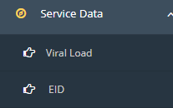

#### Viral Load

Allows you to search for records entered by each region, add, edit and delete Viral Load

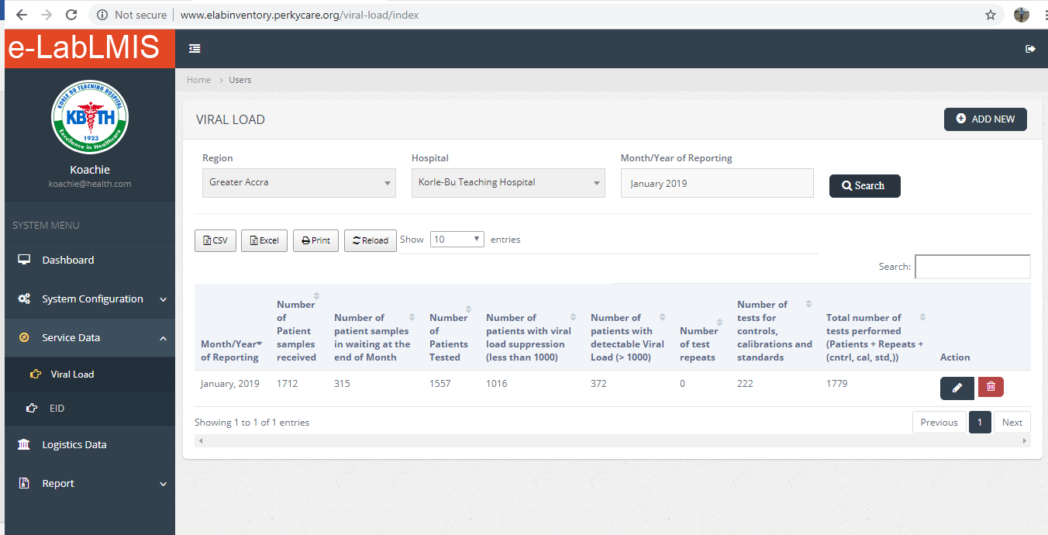

Figure : Viral Load

From Figure 19 there is a table listing all the Viral Load which allows you to search for Viral Loads for each regions records, by selecting the Region, Facility and Month\Year of the Report and click on search and displayed in the table it also allows you to add, edit and delete.

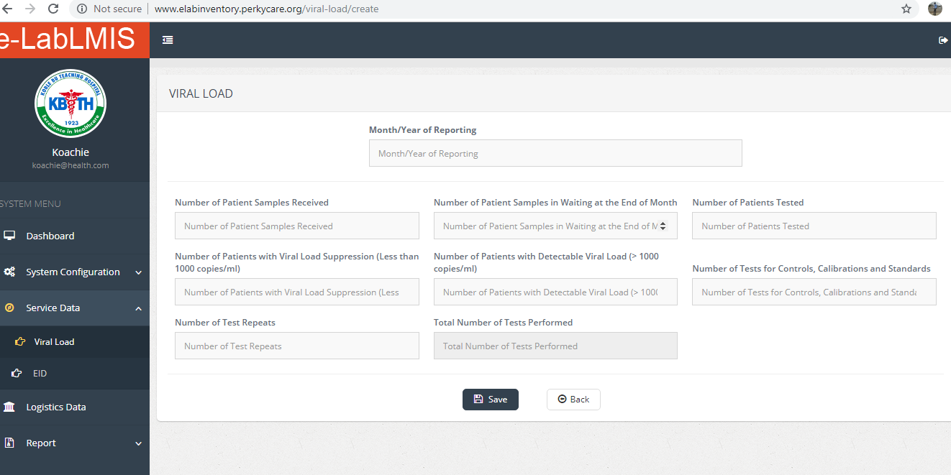

Figure : Add New Viral Load

From Figure 20 it allows you to add a new Viral Load, this done by filling the input fields and clicking on the save button to save the record. The back button return you to the list of records in the system.

Figure : Edit Viral Load

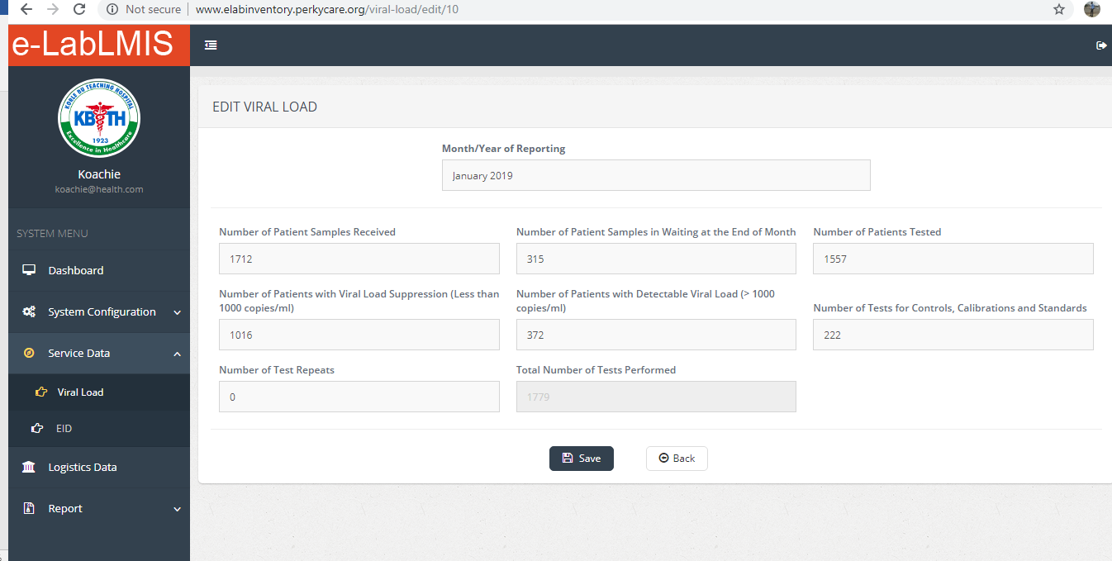

From Figure 21 it allows you to edit Viral Load, this done by making changes to the record in the fields and clicking on the save button to save the record. The back button return you to the list of records in the system.

#### EID

Allows you to search for records entered by each region, add, edit and delete EID

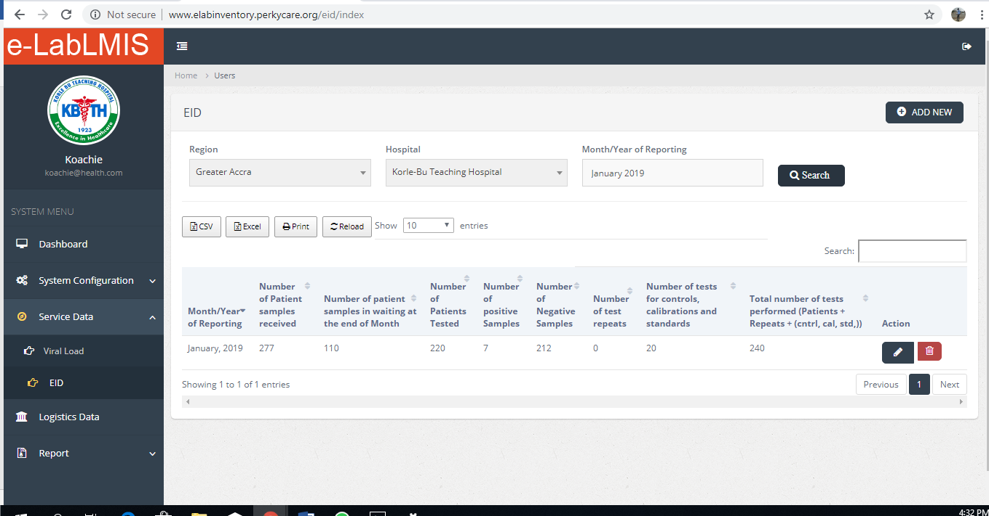

Figure : EID

From Figure 22 there is a table listing all the EID which allows you to search for EID for each regions records, by selecting the Region, Facility and Month\Year of the Report and click on search and displayed in the table it also allows you to add, edit and delete.

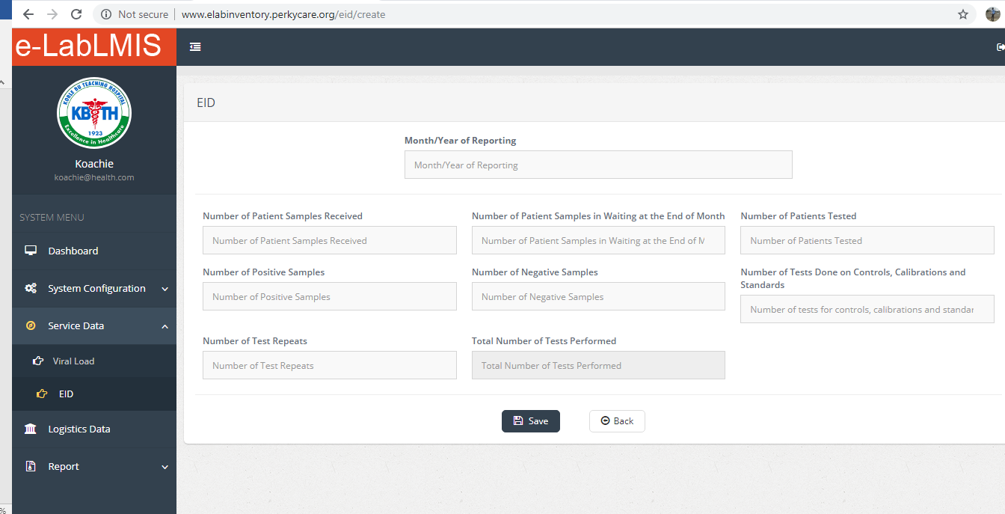

Figure : Add New EID

From Figure 23 it allows you to add a new EID, this done by filling the input fields and clicking on the save button to save the record. The back button return you to the list of records in the system.

Figure : Edit EID

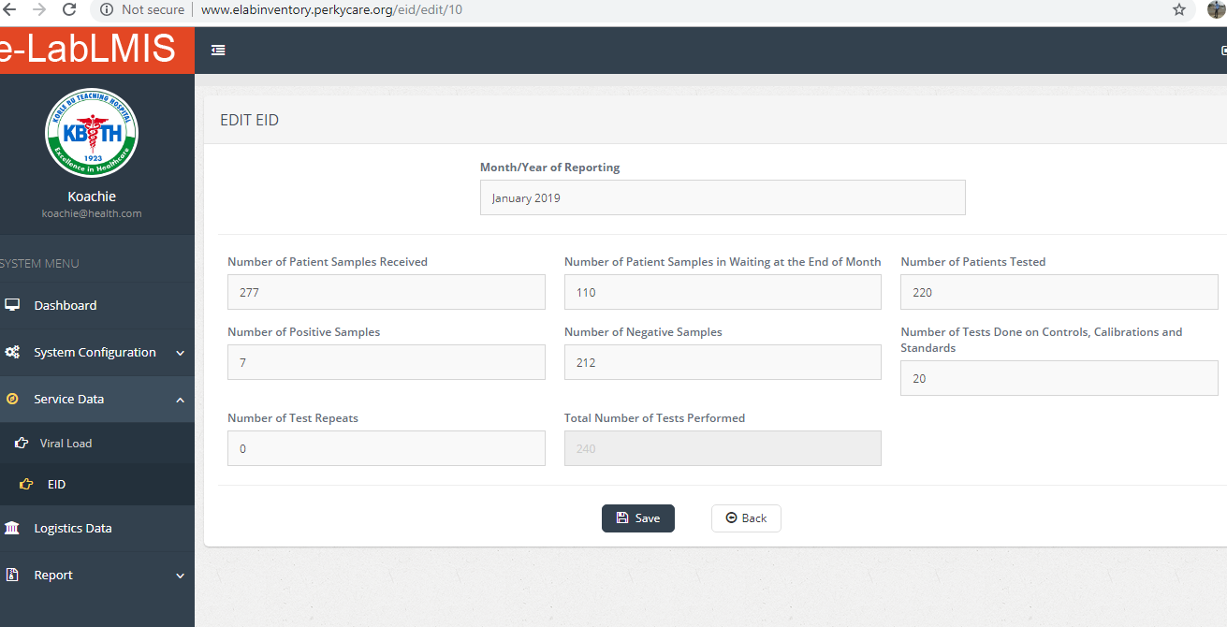

From Figure 24 it allows you to edit EID, this done by making changes to the record in the fields and clicking on the save button to save the record. The back button return you to the list of records in the system.

## Logistics Data

The e-labLMIS Logistics Data allows you to enter records into the system. The various pages of this section are explained in the following pages:

### Summary:

The navigation displays Logistics Data



#### Logistics Data

Figure : Logistics Data

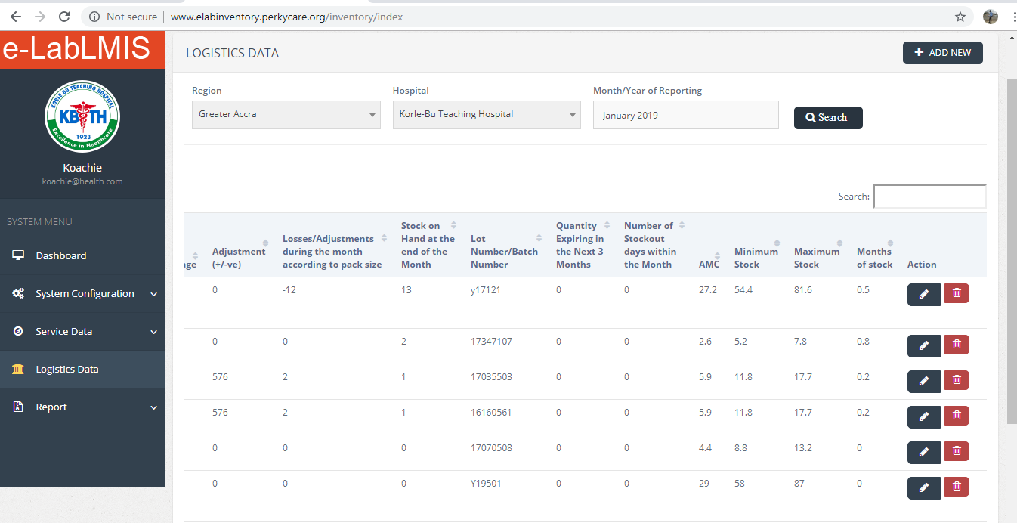

From Figure 25 there is a table listing all the Logistics Data which allows you to search for Logistics Data for each regions records, by selecting the Region, Facility and Month\Year of the Report and click on search and displayed in the table it also allows you to add, edit and delete.

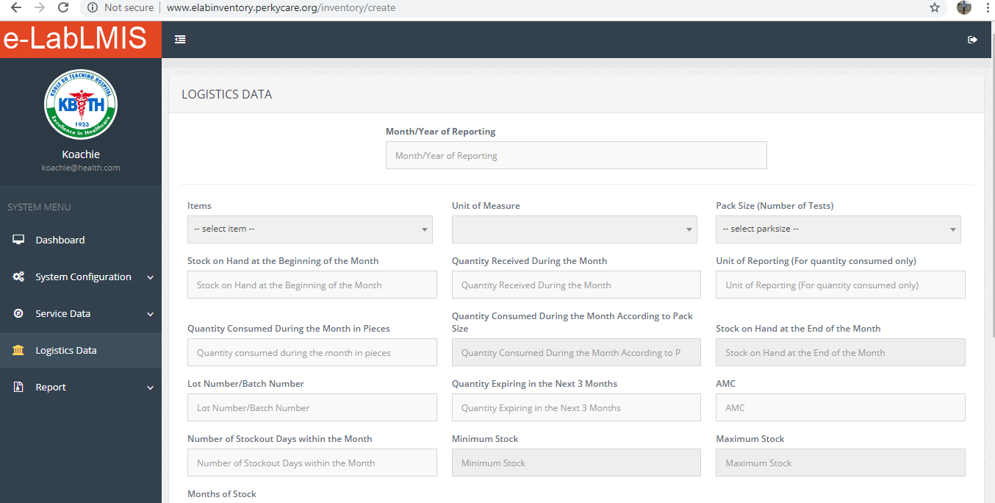

Figure : Add New Logistics Data

From Figure 26 it allows you to add a new Logistics Data, this done by filling the input fields and clicking on the save button to save the record. The back button return you to the list of records in the system.

Figure : Edit Logistics Data

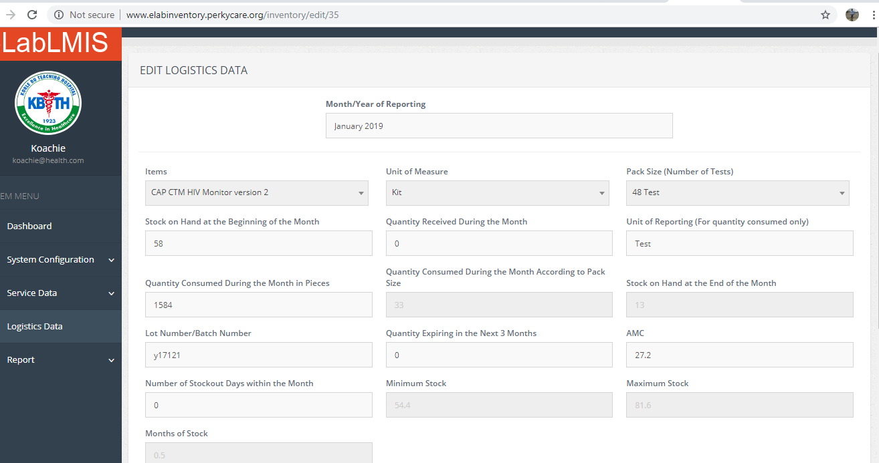

From Figure 27 it allows you to edit Logistics Data, this done by making changes to the record in the fields and clicking on the save button to save the record. The back button return you to the list of records in the system.

## Report

The e-labLMIS Report allows you to generate system Report by Regions, by Date and Region, and Periodic Report. This is done on the same page by clicking on the tab of the navigation. This is done by the System Admin/National Admin

The various pages of this section are explained in the following pages:

### Summary

This navigation displays the Service Data Summary, Logistics Data Summary, Consolidated Report, Visualized Data and Audit Trail

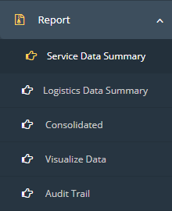

#### Service Data Summary

The Service Data Summary allows you to get report on Viral Load and EID. At the top right corner there are two buttons that enables you to navigate to the report of we wish you can click on Viral Load or alternatively EID Report to get the report you wish for.

##### Viral Load

Select the Report Type and fill the fields that will be displayed and click on the search button to get the records

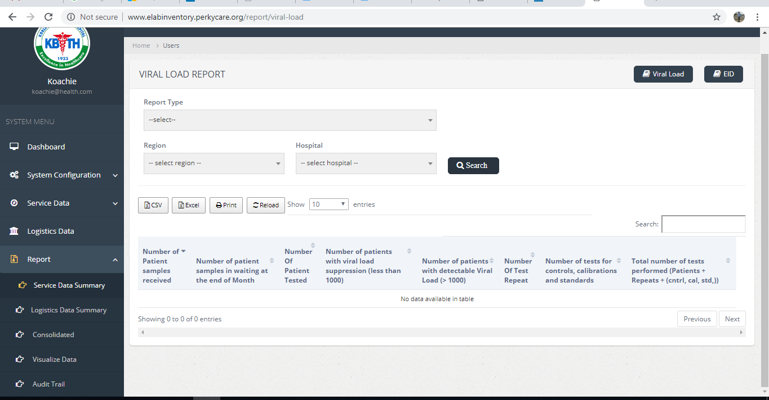

Figure : Viral Load Report

##### EID

Select the report type and fill the input fields that will be displayed and click on search to get the report.

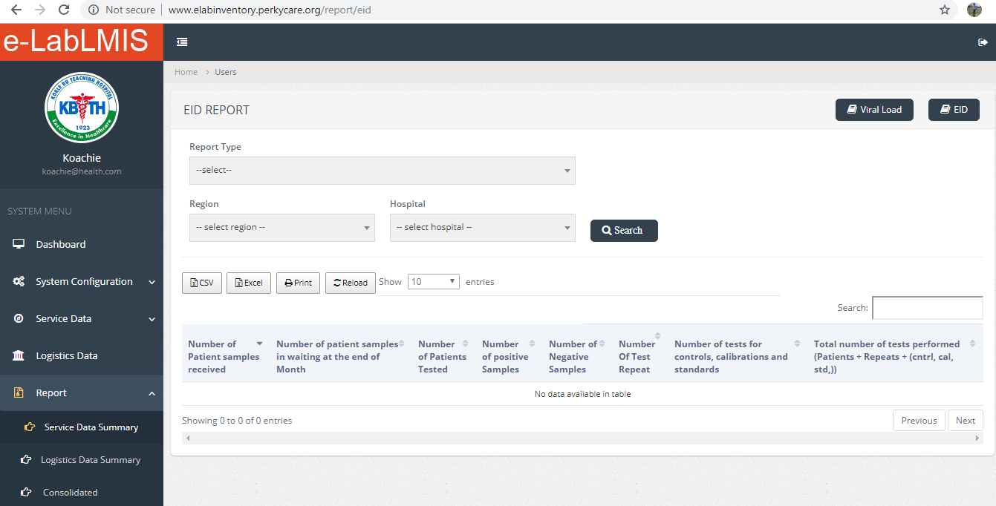

Figure : EID Report

#### Logistics Data Summary

Select the report type and fill the input fields that will be displayed and click on search to get the report.

Figure : Logistics Data Report

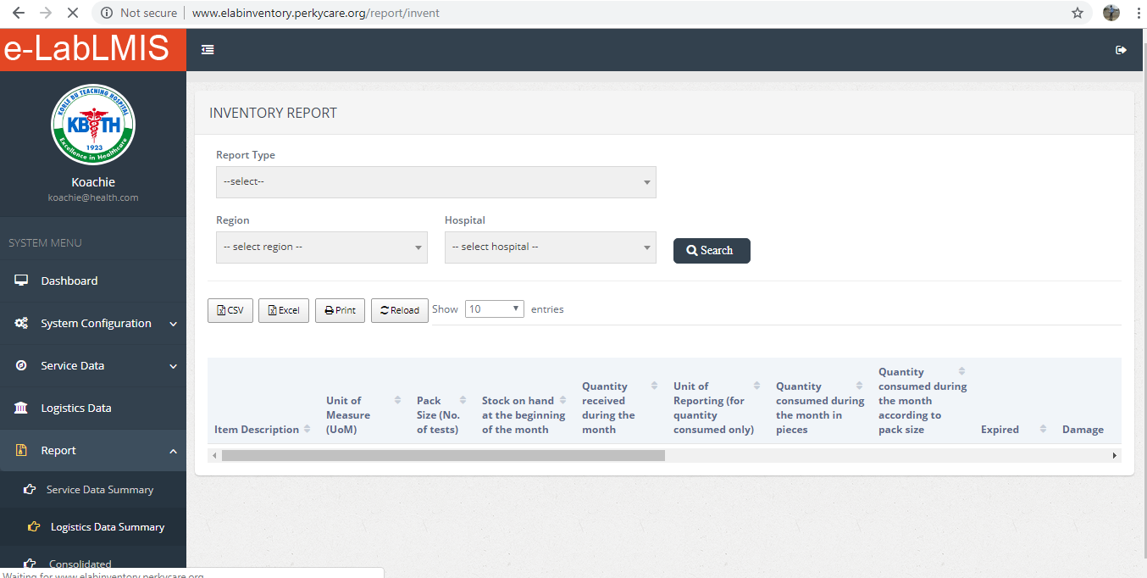

#### Consolidated

Select the report type and fill the input fields that will be displayed and click on generate to get the report, this downloads the report for the user to be either printed as a hard copy.

Figure : Consolidated Report

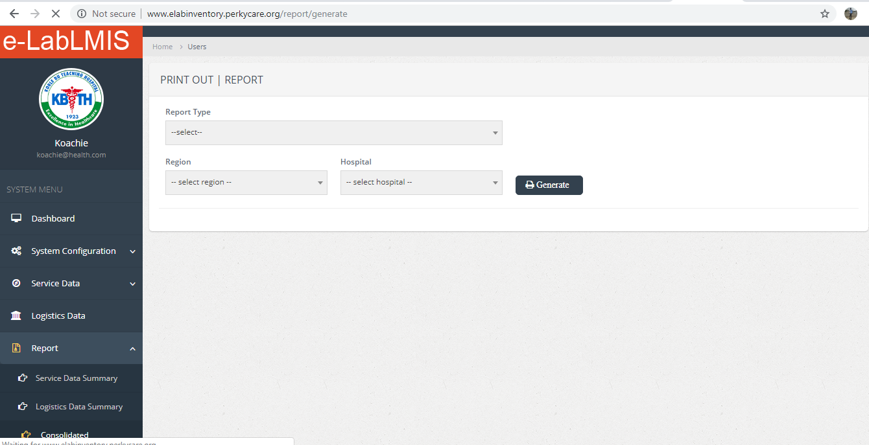

#### Visualized Data

The visualized Data Report gives a graphical representation of data in the system by selecting the Month and Year of Report and clicking on the search button, this graphical report can be printed when you click on the print button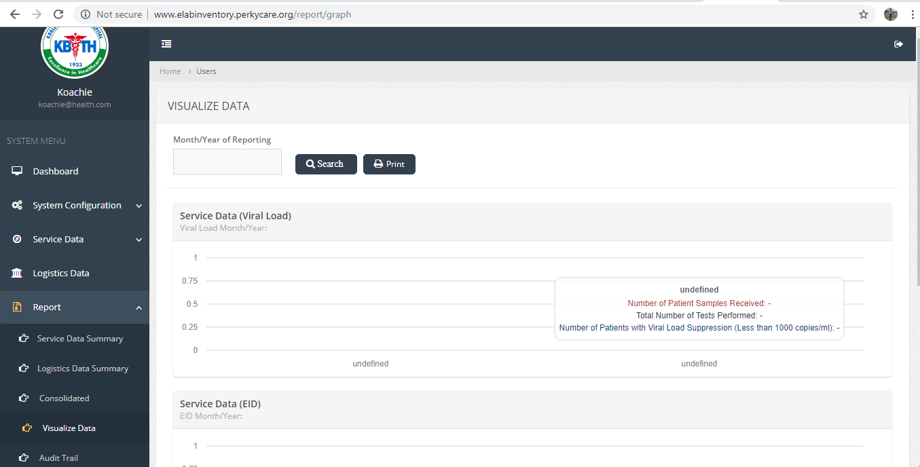

Figure : Visualized Data Report

#### Audit Trail

This Report gives a general over view of what goes on in the e-LabLMIS.

Figure : Audit Trail Report

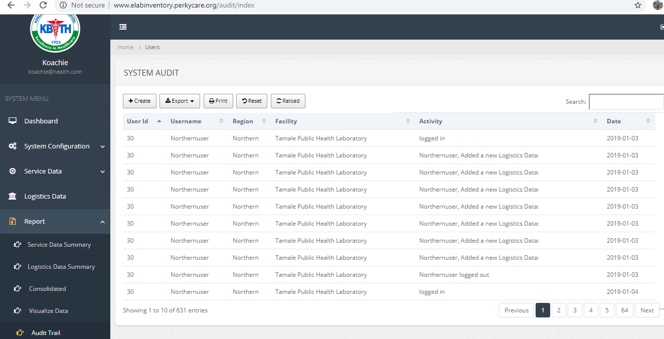

# Regional Admin Overview

The Regional Admin gives you the ability to add, edit and delete users as well as change the some system configuration settings to suit their Regions. As a Regional Admin you can also print and generate report as well as also see the data that is being entered in for the Region you are an administrator to.

When you log in as a Regional Admin, you can see the Regional Admin home page. Refer to figure 1

## System Configuration

This navigation displays the Items, Unit of Measure, Users and Roles

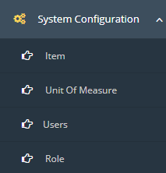

How these navigation works has been explained from figure 2 to figure 15.

## Service Data

The e-labLMIS Service Data allows you to enter records into the system. The various pages of this section are explained in figure 19 to figure 24



## Logistics Date

The e-labLMIS Logistics Data allows you to enter records into the system. The various pages of this section are explained in figure 25 to figure 27.

C:\Users\Nana Kwame\AppData\Local\Microsoft\Windows\INetCache\Content.Word\Screenshot (127).png

## Report

The e-labLMIS Report allows you to generate system Report by Regions, by Date and Region, and Periodic Report. This is done on the same page by clicking on the tab of the navigation. This is done by the Regional Admin

The various pages of this section are explained in figure 28 to figure 33



# User (System User) Overview

The User gives you the ability to add, edit and delete Service Data and Logistics Data as well as see a general overview of all Regions Activities. When you log in as a User’s, you can see the Users home page.

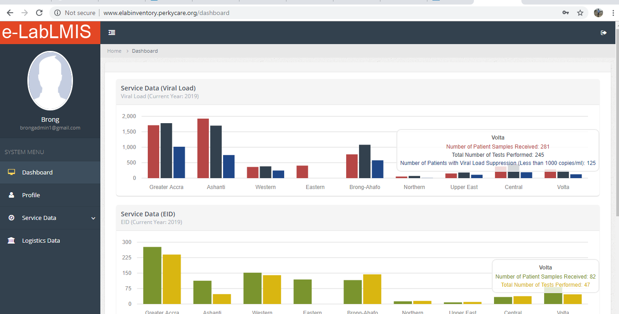

Figure : Users Home Page

## Profile

The e-labLMIS Profile allows a User to make changes to some Personal Information.

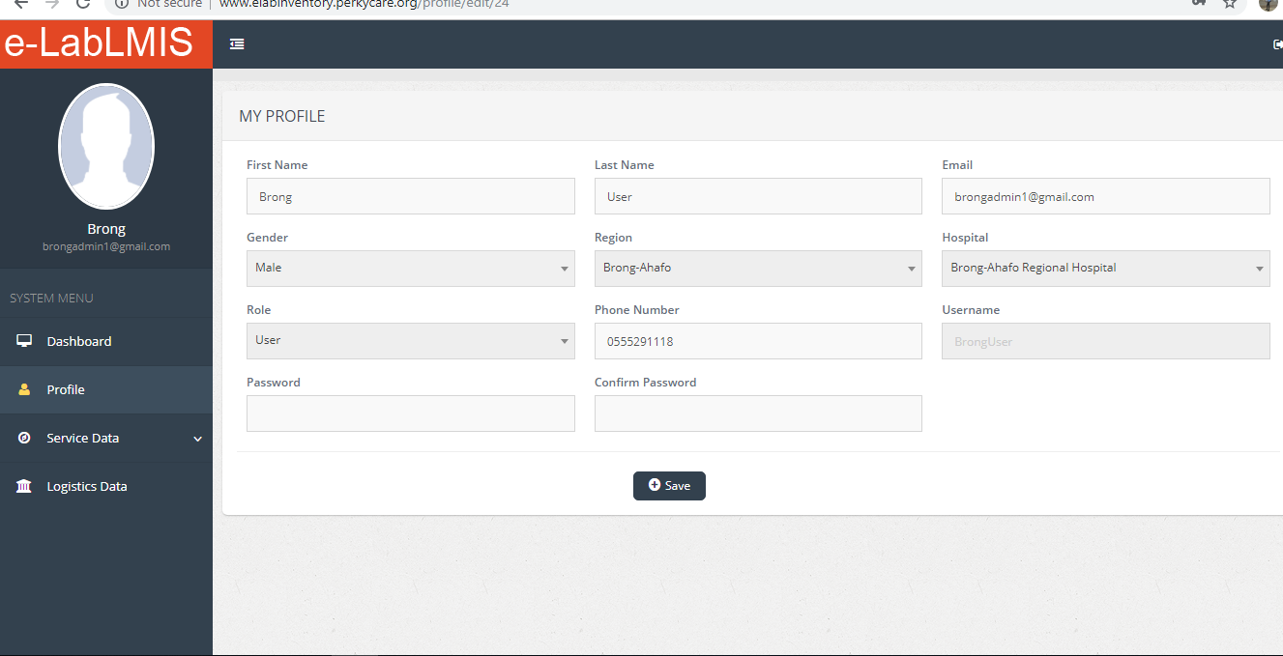

Figure : User Profile

From Figure 35 it allows you to make changes to some personal information, this is done by making changes to the record in the fields and clicking on the save button to save the record.

## Service Data

The e-labLMIS Service Data allows you to enter records into the system. The various pages of this section are explained in figure 19 to figure 24



## Logistics Date

The e-labLMIS Logistics Data allows you to enter records into the system. The various pages of this section are explained in figure 25 to figure 27.

C:\Users\Nana Kwame\AppData\Local\Microsoft\Windows\INetCache\Content.Word\Screenshot (127).png